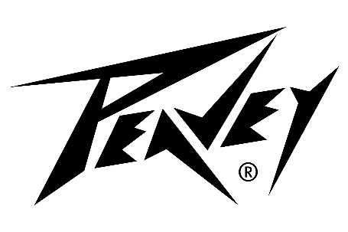
PRODUCT INFO
MAX® 100

Description
MAX Sound. MAX Flexibility. MAX Portability. MAX You.

Designed especially for performing bassists, the MAX 100 features an angled baffle which allows players to direct the sound right where they want it. With durable yet ultra-lightweight construction, the MAX 100 delivers plenty of power and state-of-the-art tonal quality.
MAX SOUND
From your most nuanced notes to chest rattling performances, the MAX 100 is ready. The built-in Kosmos®-C bass enhancement feature adds harmonics and subharmonics to give you maximum tone. Also included is an advanced version of our DDT™ speaker protection technology. This clip-limiting tech is great for slapping and other loud playing scenarios.
MAX Flexibility
Whether you are live on stage, recording, or rehearsing, the MAX100 has the capabilities you need. Click on the bass-specific chromatic tuner for a quick tune up. Utilize the external speaker out or EFX loop to flex to your needs. The ultra-quiet DI output is perfect to allow you to connect with the P.A. system while retaining control and assuring a great tone.

MAX Portability
Enjoy the best in class power-to-weight ratio. The PEAVEY Team has carefully selected lightweight woods, utilized an efficient power amp, and tended to every design aspect to maximize portability.
MAX You
With MAX 100, you will hear yourself loud and clear with no need to tilt your amp back. Thanks to the MAX 100’s angled baffle design, the sound is directed right where you want it.

MAX® 100 - Features
- 100 watts of total power
- 10“ premium speaker
- DDT™ speaker protection
- Unique angled baffle design removes the need to tilt the amp
- Pre-gain control with TransTube® gain boost
- 3-band EQ with switchable Mid-center-frequency and Bright-boost
- Kosmos-C subharmonic generator
- Overdrive circuit (footswitchable)
- Precision balanced DI with ground lift
- Tuned, ported enclosures
- FX loop
- Passive & active Inputs
- 1/8" aux input
- 1/8" headphones output
- Overdrive and Mute footswitchable
- Chromatic tuner with mute
- Unique cabinet design allows for superior high-frequency dispersion in tight spaces

